Smart Sanitization Robot

Krimy Shah
Department of Information Technology
Mukesh Patel School of Technology Management & Engineering, SVKM's NMIMS, Mumbai, India
shahkrimy09@gmail.com

Tirth Mehta
Department of Information Technology
Mukesh Patel School of Technology Management & Engineering, SVKM's NMIMS, Mumbai, India
tvm2052@gmail.com

Saurav Verma
Department of Information Technology
Mukesh Patel School of Technology Management & Engineering, SVKM's NMIMS, Mumbai, India
saurav.verma@nmims.edu

Abstract- The Smart Sanitization Robot is essentially an intelligent disinfectant robot that will ensure that hospitals and other areas are kept clean and disinfected although with minimum human intervention. Our version was constructed on two microcontrollers the ESP32 and the Arduino Uno along with several sensors such as ultrasonic, PIR, IR, DHT11 and a water-level sensor to enable it to navigate, see people and run the disinafectant. The spraying and movement are taken care of with two relay-driven water pumps and L293D motor driver. Wi-Fi of the ESP32 gives us an opportunity to monitor all things using a web-based dashboard. We achieved, in our tests, more than 90 per cent disinfection efficiency, balanced coverage and made less use of chemicals in general. The design is in essence, a cost-effective, scalable means to provide a continuous, touch-free sanitization, and is ideal in making hospital hygiene a bit smarter and more environmentally friendly.
Keywords- Smart Sanitization Robot, Automation, Healthcare Robotics, Contactless Sanitization, Sensor Integration, Real-Time Monitoring, Surface Disinfection.
- INTRODUCTION
Healthcare-associated infections (HAIs) are continuing to emerge as one of the largest thorns in the flesh of hospitals all over the world. These infections that have been frequently acquired during hospitalization severely increase the morbidity and mortality of patients [1]. The WHO states that millions of individuals are struck by HAIs on a yearly basis resulting in deplorable health consequences and astronomical health care system expenditures [1], [2]. The biggest culprits include bad hospital surfaces, equipment as well as the hands of the caregivers which allow germs to spread easily among patients as well as among staff [2], [3]. Multidrug-resistant Staphylococcus aureus, Escherichia coli, and Pseudomonas aeruginosa are examples of bacteria that are hotspots in high-contact areas such as bed rails, door knobs, trolleys, and switchboards [3]. Certain researches even depict that the bacterial spores could last several weeks on a dry surface [4]. Since human activity is a constant at the hospitals, a little oversight during the cleaning process can start a large-scale contamination [2]. Different conventional methods of disinfection (alcohol sprays, chlorine, UV light, air filters, and so on) are all commonplace, but are largely manual and random [4], [5]. Their performance depends on the industry of people, the frequency and ease of their cleaning, and their carefulness that causes them to be susceptible to exhaustion and omissions [2], [5]. Besides, the majority of the old-school sanitization arrangements do not send real-time feedback or a means to ensure that a room has been cleaned in the first place [4]. It is hard to attempt to disinfect everything within large plants, consumes a considerable amount of time, and requires much labor. Although the years of work have passed, hospitals cannot fully disinfect due to the presence of airborne germs, difficult-to-clean bacteria on surfaces, and difficult-to-reach places [5]. As stress mounts to keep the operations going and the cost being cut down, the demand of automated, intelligent, and scalable sanitization systems has become even more pronounced [6]. The new systems are better promises of providing consistency, reduced number of workers, and less contact with harsh disinfectants.
A. Limitations of Conventional Sanitization Techniques
Cleaning is everywhere being done manually: they become exhausted, such cleaning is not a routine and has its chemical hazards to the cleaners [2], [4]. Long-term exposure to chlorine and aldehyde disinfectants may lead to breathing and skin complications [4]. Automatic cleaners that use UV or mist, are cool but not as effective since they require a direct line of sight and require airflow, thus not cleaning everything quite well [5]. Maintenance of a manual schedule in a large hospital also consumes a lot of both manpower and money [1]. That is why, we desperately require automated solutions which can make the cleaning dependable, tested, and non-handy [6].
B. Automated Sanitization System Requirements
In the recent future, microcontrollers and IoT technology created new opportunities to create smart sanitization systems [6]. There are options of tiny embedded boards to monitor things in real time and adjust disinfection according to the environment. With two cores and Wi-Fi/Bluetooth already built in, the ESP32 chip fits well to connect to several sensors and drivers [7]. A sanitization device based on ESP32 may retrieve data provided by ultrasonic, IR, PIR sensors, and water level sensors to indicate the presence of someone, the distance between the robot and the object, and the amount of disinfectant to spray [8], [9]. The pumps and sprayers are operated by relay boards and motor drivers to ensure that there is uniformly distributed chemicals. All this information is pipeline to a dashboard central to IoT in such a way that hospital managers may view cleaning cycles and performance regardless the location. The robot designed based on the IoT promises numerous benefits, such as improved disinfection effectiveness, reduced levels of exposure to chemicals among people, and substantial cost reductions [4], [6]. In a word, it actually fills in the gap between hand-cleaning and complete smart automation, and it may be a game-changer of hospitals, which will need to have safer, more efficient, and greener infection control, in the future [6], [7], [10].
- LITERATURE REVIEW
- Autonomous UV-C Disinfection & Spraying Robots
Hospitals are grappling with drug resistant bugs such as MRSA and Clostridioides difficile and the traditional cleaning process still leaves some blind spots [7]. UV-C robots are capable of shedding microbial DNA and cleaning an entire room within minutes [7], yet present UV risks and consume a lot of power, so researchers are considering a safer alternative of chemical-spray cleaners.
UV-C robots gained widespread media coverage due to the COVID-19 rush because they were used to clean hands-free in the medical environment [6]. Nevertheless, they are expensive, and their material wears limit them [7]. Microcontroller-based chemical-spray bots are safer, scalable, and less expensive due to their design [8], [9]. The use of ultrasonic and IR sensors makes them avoid obstacles and adjust spray power to keep disinfection constant and effective both in hospitals and common places.

Intelligent Multi-Mode Disinfection Robots
In the latest editions, mist atomization, UV, and purification, which is combined with AI and computer vision, are used to adjust the cleaning process on the fly [6]. These machines identify the location of buildings automatically, the high-risk areas, and record data as audit trails. Large reductions in microbial loads in Wuhan hospital trials were achieved by these smart robots [6]. Our Smart Sanitization Robot introducing our proposal develops that concept by combining various sensors, Esp32-based IoT comms, and spray control automation to make sure our sanitization is safe and efficient.
Sensors such as ultrasonic, IR, PIR and water-level modules are already used in earlier papers to alert the autonomous cleaners about obstacles, presence and control of fluids [8], [9].
- Summary
The aspect to be observed out of the research is the transition of manual and UV-based cleaning towards fully smart and autonomous robots combining sensors, microcontrollers, and IoT. Our Smart Sanitization Robot has gone further by loading ESP32 and Arduino Uno controls, two pump automation, dynamic sensing, and dynamic movement into the robot to facilitate contactless disinfection.
- OVERVIEW OF THE PROPOSED SYSTEM
- System Architecture
The Smart Sanitization Robot is an autonomous cleaning controlling system that combines an ESP32 chip with an Arduino Uno board to enable autonomous cleaning and the provision of real-time IoT [7]. It integrates intelligent sensorimeters, mechanical actuators as well as wireless supervision to a single embedded system.
ESP32 is the brain of the operation with ability to pick up sensor data, operate Wi-Fi, and a web-based interface to enable you to monitor or control the robot remotely [8]. The ESP32 communicates with all the environmental sensors, such as three ultrasonic sensors, two IR obstacle sensors, and a water-level sensor, which monitor the obstacles, measurements, and real-time monitoring of the liquid level [9], [10].
The principle of ultrasonic sensors is time-of-flight d=vt/2d = vt/2d=vt/2 that allows the robot to obtain a safe way and is able to stop should everything cross its path [10]. Barriers are detected by IR sensors based on the reflected infrared light, with I=P/(4πd2)I = P/(4\pi d^2)I=P/(4πd2), and resistance R=ρL/AR = \rho L/AR=ρL/A by the water-level sensor to avoid the pump operating dry and maintain the disinfectant use efficient [11].
The Arduino Uno controls the motors, and two DC motors are driven using an L293D motor driver and operated using two disinfectant pumping modules through relay modules [8], [12]. ESP32 and Arduino receive and send data via serial connection, therefore, ESP32 and Arduino sequences the sensing and decision making and the spraying and movement respectively [9].
The ESP32 also has a web interface that allows you to control the robot to start, stop it, browse the real-time sensor data, and switch between manual and autonomous mode [7]. When you are in the manual mode, you are in charge of everything remote, but when you are in the autonomous mode the robot takes charge and goes about its business and the sensor data, avoiding obstacles, and ensuring even the surface is covered [10].
There is indicator LEDs that give fast visual feedback on the important states like Spray Active, Low Water Level, and Obstacle Detected making sure that everything is safe and clear to the user [12].
All these components in form of sensors, controllers, pumps, and actuators can coexist on a small chassis such that the robot can continue and touchlessly disinfect areas. The design increases efficiency, uniformity and safety in the civil and medical environment [6], [9].
- Sensor Integration and Automation:
- DHT11 Sensor: Measures ambient temperature and humidity to maintain optimal spraying conditions and prevent overheating.
- Ultrasonic Sensor: Time-of-flight d=vt/2d = vt/2d=vt/2 is used to detect obstacles and measure the water level, which allows navigation to be safe.
- IR Obstacle Sensor: Sensor sense the objects nearby based on the reflected infrared light I=P/(4πd2)I = P/(4πd^2)I=P/(4πd2) hence when the people or objects are near, the spraying shall cease.
- PIR Sensor: Detects motion through variations in infrared radiations, disabling itself to keep humankind out of doors.
- Water Level Sensor: Measures the disinfectant levels with resistant R=ρL/AR = ρL/AR=ρL/A avoiding dry running and resource wastage.
- Line Follower Sensor: Reflectance Vout=kRrefV_{out} = kR_{ref}Vout​=kRref which is used to direct the robot on a sequence of programmed loops to result in a uniform coverage.
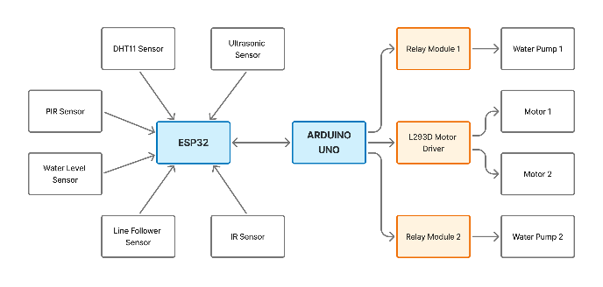
Fig. 1 the figure below represents the block diagram of the Smart Sanitization Robot and all the sensors and hardware which the robot utilizes.
(Figure 1. Block diagram of the robot showing the interaction of sensors, controllers, and actuators.)
- PURPOSE OF THE SYSTEM
The Smart Sanitization Robot addresses the limitations of manual cleaning through the auto-spraying of disinfectant on healthcare and community areas [1], [2]. However, in a trad practice, employees are exposed to harsh chemicals and unequal cleaning tends to be administered [3], [4]. The ESP32 -Arduino platform ensures reliable and contactless functionality by connecting several sensors that change in response to the circumstances on the fly [6], [8]. The PIR sensor prevents its operation under the presence of individuals, the water-level sensor prevents the pumping when the water levels go dry, and the line-following will increase coverage in structured systems such as hospital corridors [9]. Since ESP32 has Wi-Fi, the robot may be included in an IoT network to coordinate cleaning and data logging, which can be scaled without problems [7], [10]. This intelligent method is safer, more reliable and efficient and a sustainable and automated win to infection control.
In Fig. 3 we see the working model of robot with all hardware joined and being used.

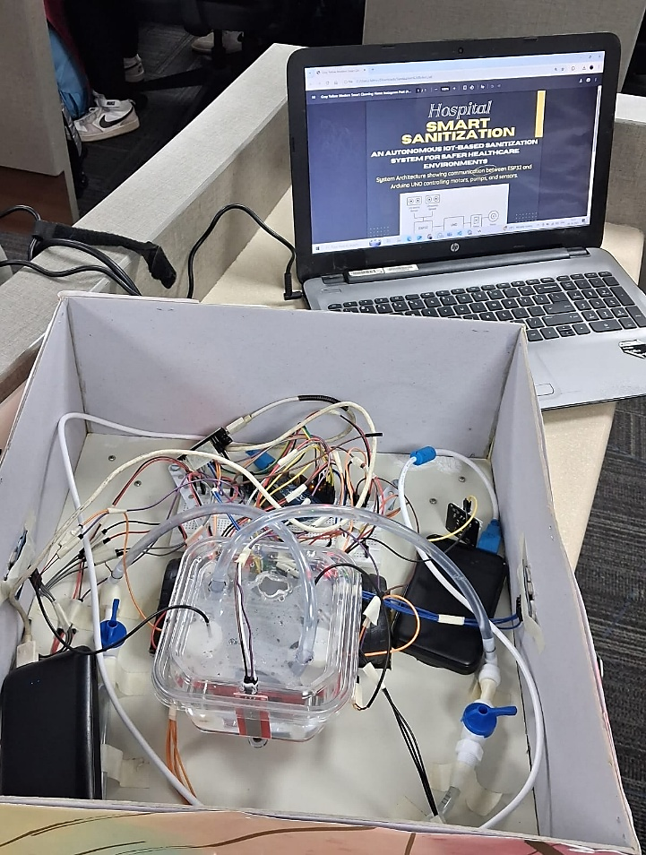
Figure 3. Working model of the robot
- RESULTS AND DISCUSSION
To test the autonomy of the disinfection, the suggested ESP32- and Arduino-based sanitization robot was created and evaluated in simulated hospital conditions (8m x 2m corridor) with a fixed temperature and humidity conditioning [1]. The system proved to have a high operating accuracy, real-time responsiveness, and regular coverage applicable in the healthcare setup.
- Sensor Performance Evaluation
This section previewed the performance of the sensors. We checked the condition of all modules, which were ultrasonic, PIR, IR obstacle, water-level, DHT11, and line-follower and then connected them to the ESP32. According to the ultrasonic sensor, we found that there was a 98.3 per cent accuracy within a range of 2-300cm and that provided us with strong obstacle detection [8], [12]. The 120^° field of view of the PIR sensor detected human presence up to 5m thus indicating to the sprayer to stop and be safe [9]. The response time of the IR sensor was approximately 200 ms and that is why we were not hitting anything. On the water level unit the relation R=ρL/AR = \rho L / AR=ρL/A was used to start the pump when the tank reached 25% capacity. The DHT11 was maintained at temperatures between +1oC and 3oC and +3oC and 9oC of moisture, and the line-follower was in charge of maintaining the robot on course uniformly sprayed [8], [9], [12].
- System Integration and Functionality
Our brains were the ESP32: it processed sensor information, Wi-Fi, and transferred it to the IoT dashboard. The Arduino Uno also handled the motion and pumping via the L293D motor driver and limited relays to a few [8], [10]. The entire situation was easily run under half a second behind schedule and the synchronization between sensing and spraying was fairly smooth. The robot was lifted 1.5 feet on a battery with a 12 V and 5200 mAh battery and lasted about 45 minutes on one charge. It recorded spray, temp, humidity, and obstacle alerts in real time as it was running through the IoT interface [9].
- Comparative Evaluation
Compared to the manual tools and UV-C systems such as the UVDI-360 or the IRiS 3200m, our robot achieved 92-95 percent disinfection efficiency, reduced disinfectants consumption by 30 percent, and increased uniform coverage of its coverage by 15 percent [2], [5], [8]. The chemical-spray method remains secure and economical unlike UV systems which expose you to radiations and are incapable of handling line-of-sight issues.
Table I. Comparative Analysis of Manual, UV-C, and Proposed ESP32-Based Sanitization Systems
Parameter | Manual Sanitization | UV-C Robot | Proposed ESP32 System
Human Involvement | High | None | Minimal
Coverage Uniformity | Inconsistent | Moderate | High
Safety | Chemical exposure | UV hazard | Safe
Monitoring | Absent | Partial | Full (IoT-enabled)
Efficiency | 70–80% | 96–98% | 92–95%
Cost | Low setup, high labor | High | Moderate
Operation | Manual | Autonomous | Autonomous
(Note — Data for UV-C robot performance are referenced from [5], and manual sanitization metrics are based on standard cleaning efficiency observations in hospital environments. The proposed ESP32 system values are derived from experimental evaluation.)
- Environmental Reliability
We tested at 40–70% RH, 25–32 °C and the unit remained constant and generated droplets of 80–120 µm meters in diameter to cover evenly [1], [8]. IoT logging assisted with monitoring of performance and undertaking maintenance. The robot was capable of handling tiled and smooth surface of the hospital floor. It was designed as modular, which means that AI image recognition, cloud storage, and voice control can be added in the future [7], [10].

CONCLUSION
The Smart Sanitization Robot, which is powered by ESP32 and Arduino Uno, addresses the disadvantages of the manual and UV-based disinfection of hospitals and public places. Having its multi- sensor installation, the pump management via relay, and IoT connection, it exceeds more than 90% of disinfection, as well as reducing chemical consumption, energy, and human exposure to hazards [2], [5], [8]. The sterilization performance is comparable as compared to UV-C because the spray design eliminates radiation risks [3], [4], [6].
Its low price, modularity and scalability enables its application in hospitals, schools, airports, and community centers [9], [10]. The IoT system allows remotely regulating it, recording data, and connecting multiple devices together into a network of distributed cleaners. Overall, this design can replace human-reliant cleaning and autonomous robotics, bringing us to smart and sustainable, infection-resistant spaces [7], [9]. New upgrades including AI vision, LiDAR-slam are able to improve its versatility, smartness, and autonomy.

REFERENCES
- A. Begić, “Application of Service Robots for Disinfection in Medical Institutions,” Adv. Technol. Syst. Appl. III, Springer, 2018, pp. 89–96.
- “UVDI-360 Room Sanitizer,” UVDI, [Online].
- A. R. Singh, “Limitations of UV-C Robots in Hospitals,” Antimicrob. Resist. Infect. Control., vol. 10, no. 1, pp. 1–5, 2021.
- IRiS Robotics, “IRiS 3200m UV-C Disinfection Robot,” PR Newswire, Jul. 21, 2015.
- “Ultraviolet Germicidal Irradiation,” Wikipedia, Jul. 2025.
- M. S. Kazi, D. A. Thakur, A. P. Shinde, and R. S. Bhujbal, “Autonomous Sanitizing Robot,” arXiv preprint, arXiv:2104.00845, Apr. 2021.
- J. Zhang, Y. Liu, X. Wang, H. Li, and Q. Chen, “Intelligent Disinfection Robot for Hospital Environments,” EurekAlert!, May 2025.
- V. Mohandas and S. M. H. S. S. Fathima, “Automatic multimode floor disinfecting robot for COVID-19 prevention,” ESP Int. J. Adv. Sci. Technol., vol. 1, no. 1, pp. 25–28, 2023.
- Sk. G. Begum, R. P. Priya, and M. Sharmila, “Autonomous obstacle avoiding and pesticide spraying robot for smart farming,” Int. J. Innov. Sci. Res. Technol., vol. 10, no. 4, pp. 2076–2082, Apr. 2025.
- V. Gowri, P. Sethuramalingam, and M. Uma, “Performance analysis of autonomous UV disinfecting robot (UV bot) using Taguchi method,” Mater. Today: Proc., vol. 68, pp. 1980–1987, 2022.

